P.S.181Q The Brookfield School
148-15-230th Street
Springfield Gardens, NY 11413
718-528-5807

Parent /Child Workshop
“Color Me Calm”
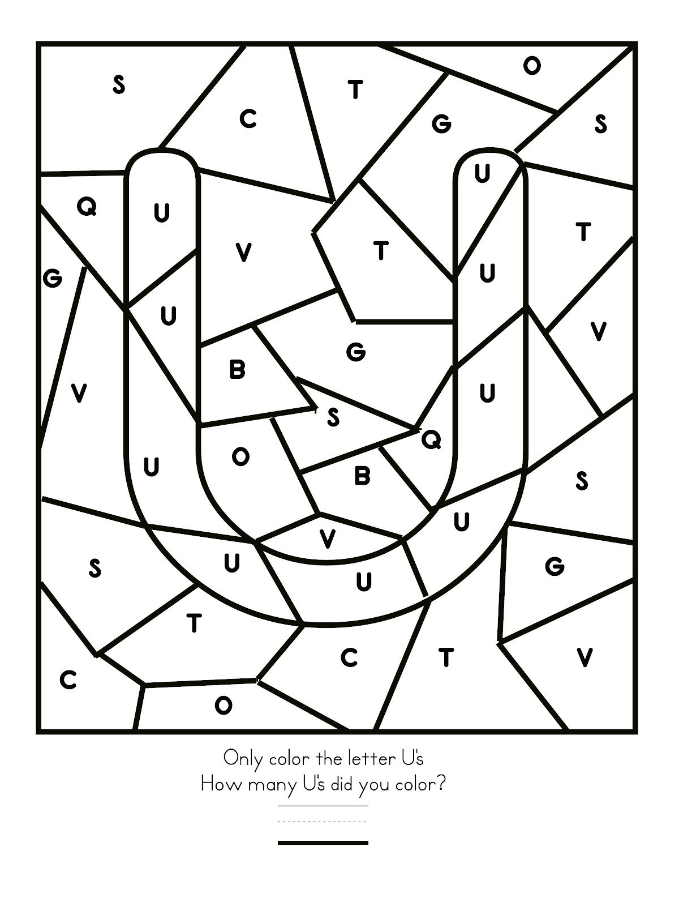
*This is a Parent /Child Parent Involvement Activity so
Parent must stay with their child*

Tuesday, September 25, 2018
Time: 2:45pm
Room 166

Please return the tear-off to Ms. Simone Brown, Parent Coordinator.

-----Yes, I will be able to attend the Parent/child Workshop.

Child’s name and class______________________________

Parent’s name and telephone #________________________

